Shop WireFrames

1.

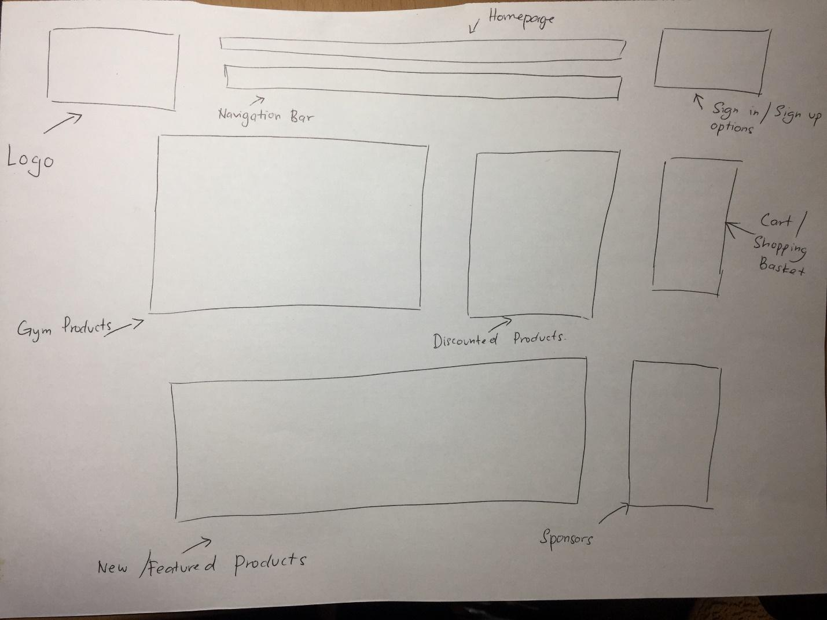

The client didn’t like the format of the new/featured products link on the bottom and would like it to be below the navigation bar. They also preferred if the link for all the gym products and discounted products to be below the new/featured products link. The next wireframe is on the next page

2.

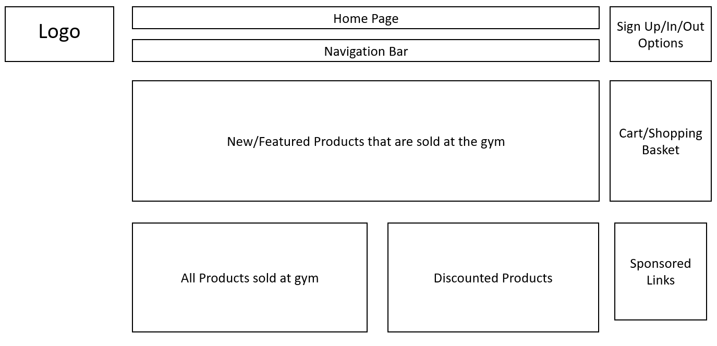

Our client seemed to like this wireframe but still finds it to be disorganized. They wanted the all products sold at the gym to be merged into one link with the discounted products, as it would be less cluttered. They would also prefer the sponsored links to be at the bottom of the page. The next wireframe is on the next page

3.

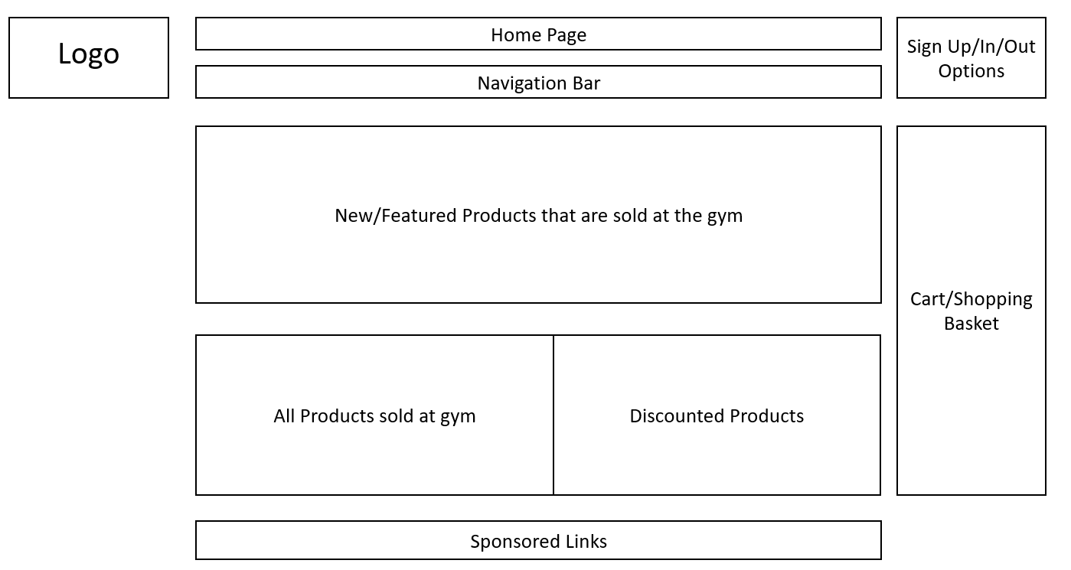

They liked this wireframe and said it was good.

Checkout

1.

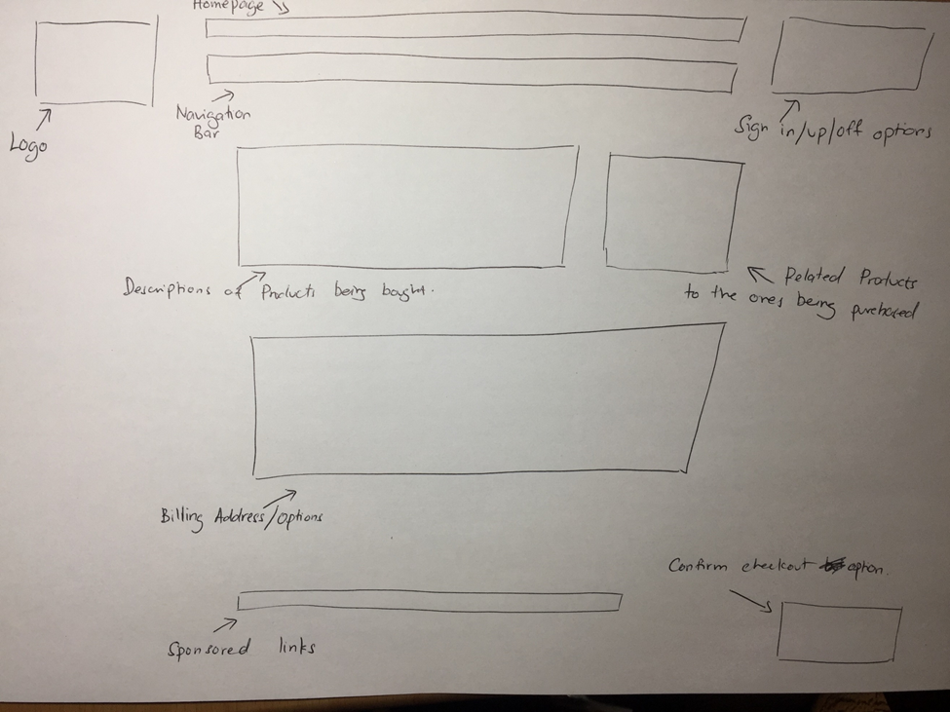

The client liked this wireframe but felt that the format is a bit messy. They wanted the format/position of the links properly situated. The next wireframe is on the next page

2.

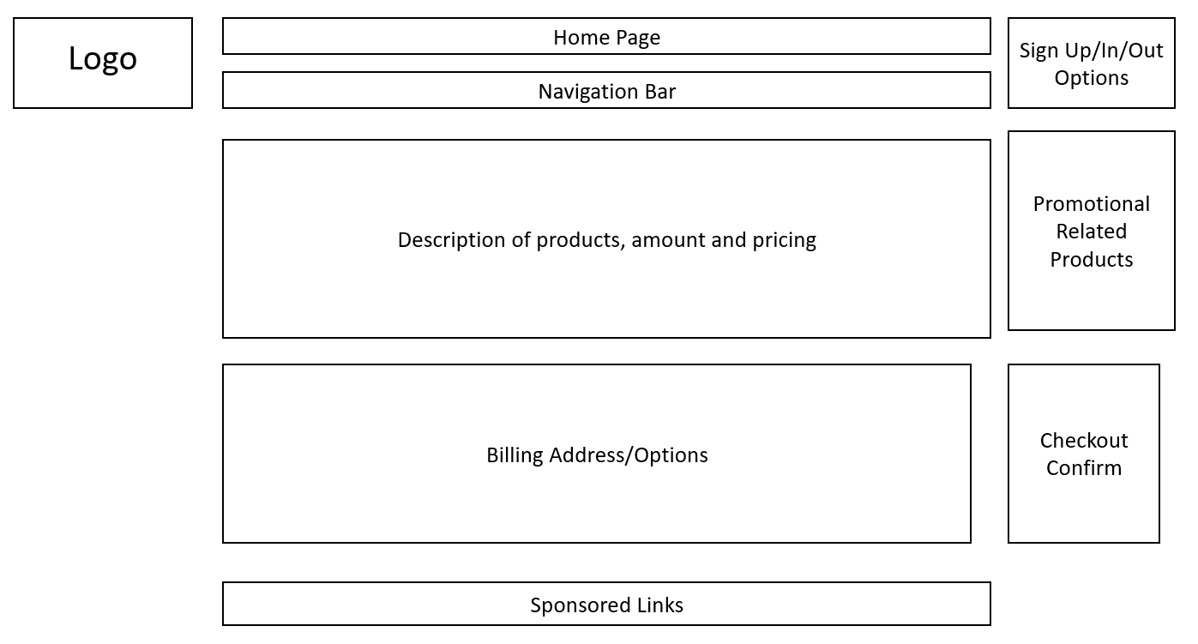

Our clients felt that this wireframe is good but could be better. They wanted to see more of the promotional related products with more pictures and the checkout confirm link to be at the bottom right of the page. The next wireframe is on the next page

3.

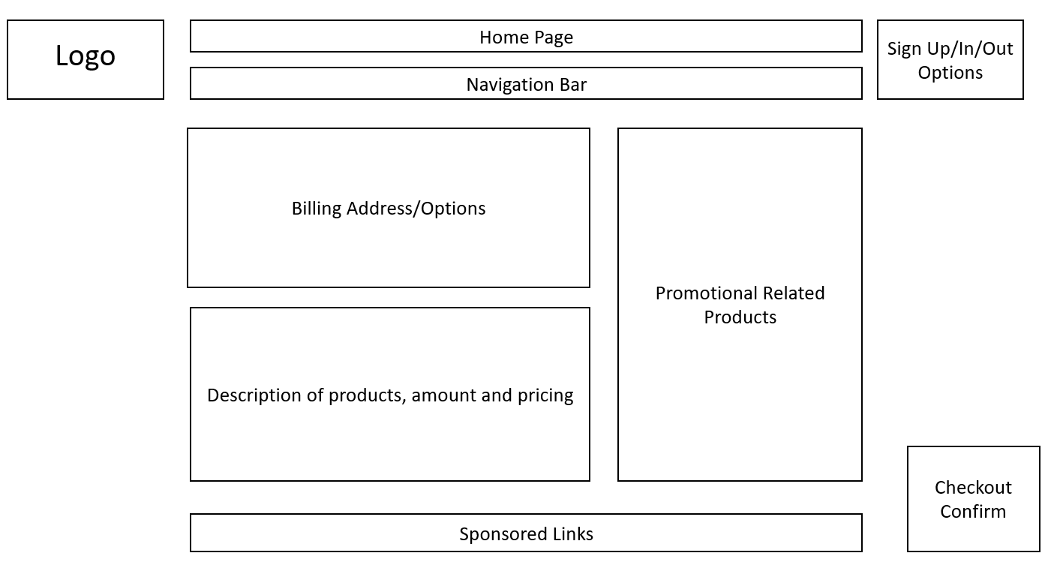

Our clients are satisfied with this wireframe and accepted it.